BODYSUIT

# Objective:

The Smith & Nephew’s BODYSUIT developed using VBA customizations need to be converted to .NET framework in compatible with AutoCAD 2018, adhering to best practices, supporting 64 bit architectures.

# Overview:

BODYSUIT has 3 functions “Body”, “Leg” and “Arm” to draw Body details, Leg details and Arm details in AutoCAD.

This document gives an outline of input details need to generate required output, working flow and output details of BODYSUIT module in Smith & Nephew project.

# Description:

# Scope:

* BODYSUIT module is used to draw Body, Leg and Arm in the standard template drawing “SN.dwt” using the details from “MAINPATIENTDETAILS” block reference.
* For BODYSUIT module, first we need to update the attributes of “MAINPATIENTDETAILS” block reference using NEWPATIENT command. Without that, we can’t run BODYSUIT module.

# Technology:

We are using VB.net technology and AutoCAD 2018 for BODYSUIT.

# Deliverable:

AutoCAD 2018 customized plug-in DLL.

# Steps to Run:

1. Open AutoCAD 2018 and open a drawing using “SN.dwt” template file.
2. Run NETLOAD command in Command prompt.
3. Load the updated “SmithNephew.dll” file in AutoCAD.
4. Run NEWPATIENT command in Command Prompt and update the attribute values in “MAINPATIENTDETAILS” block reference.
5. Run BODYSUIT command in Command Prompt.
6. “Bodysuit” dialog will be opened.
7. In that dialog, we have 3 tabs (Body, Leg and Arm).
8. Enter the required details for required Part (Body or Leg or Arm).
9. After entering details, click draw button.
10. Now, the required Body or Leg or Arm will be drawn successfully in AutoCAD.

# Dialog Design:

# Body:

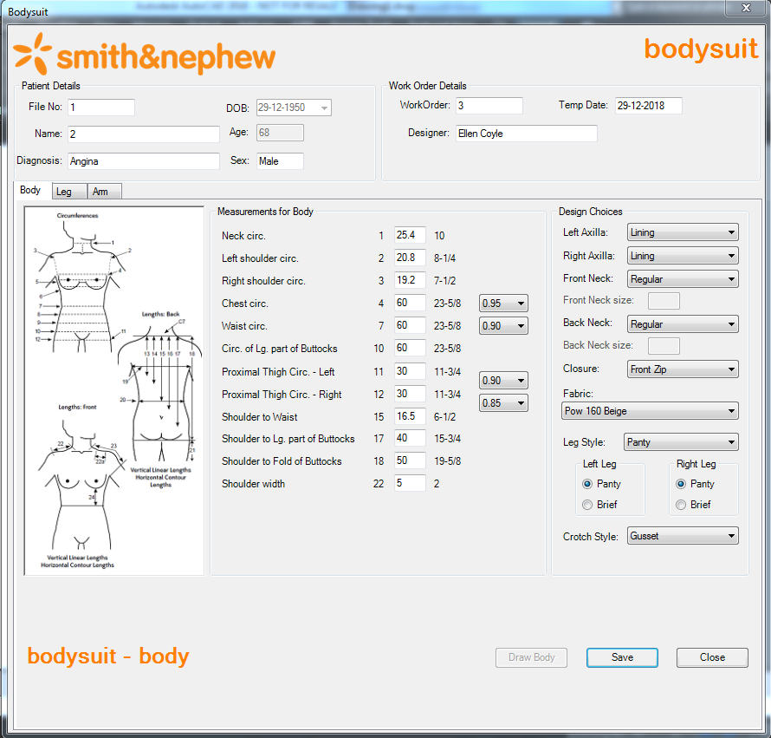

# Leg – Left Leg:

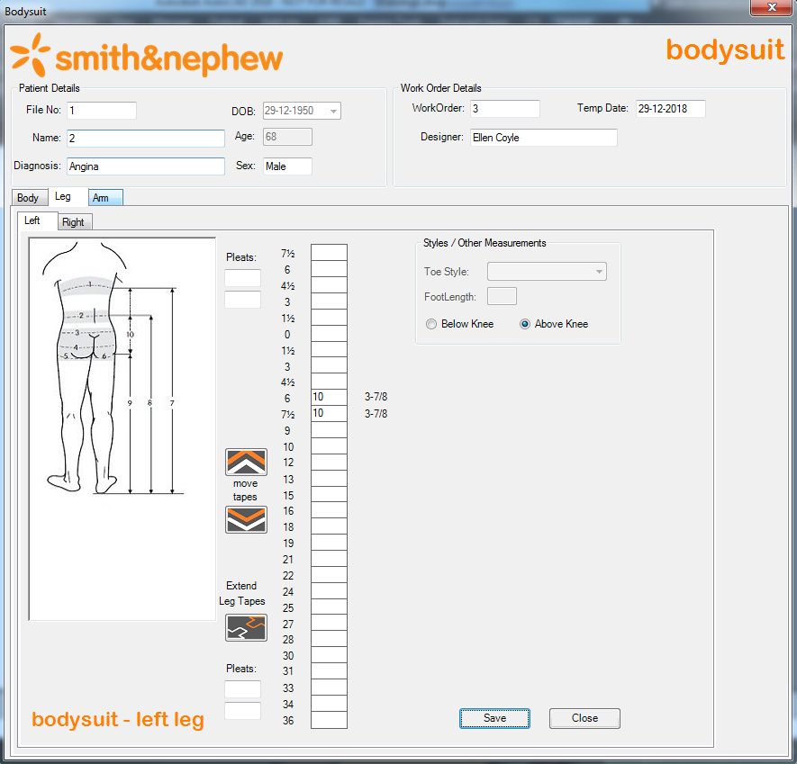

# Leg – Right Leg:

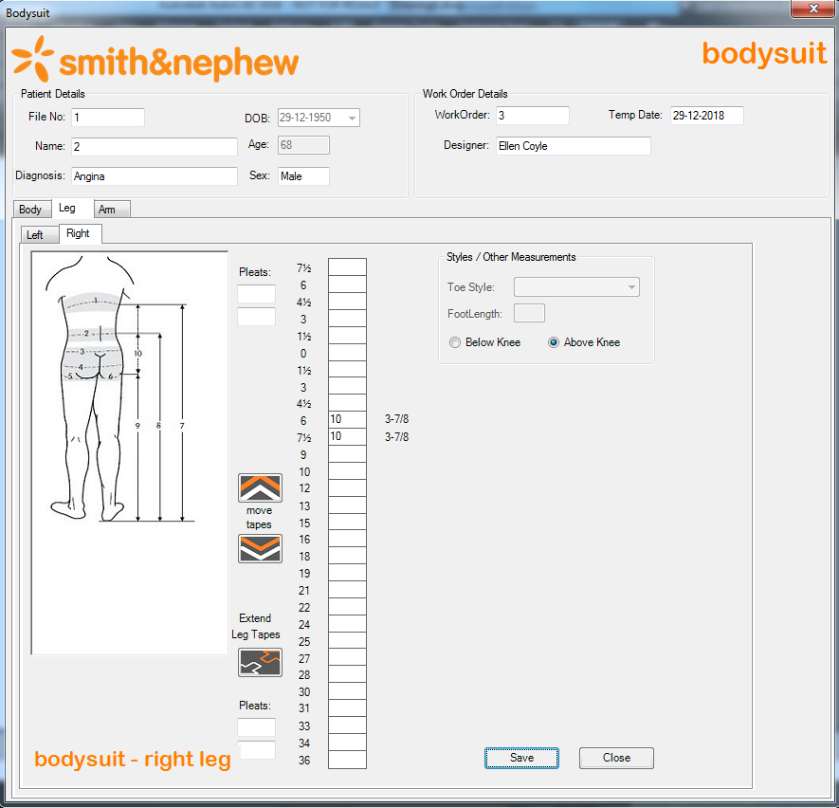

# Arm – Left Arm:

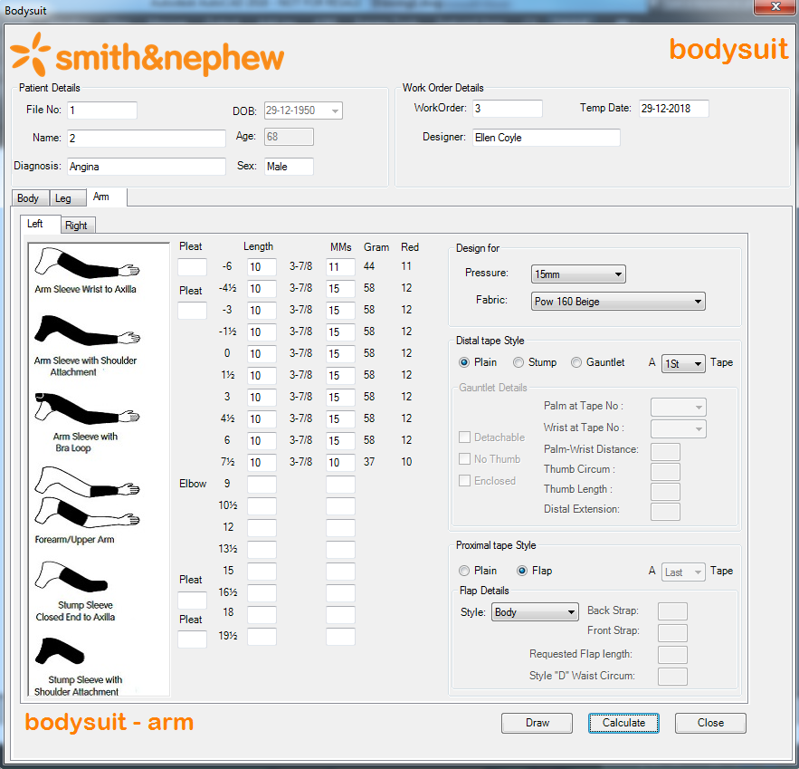

# Arm – Right Arm:

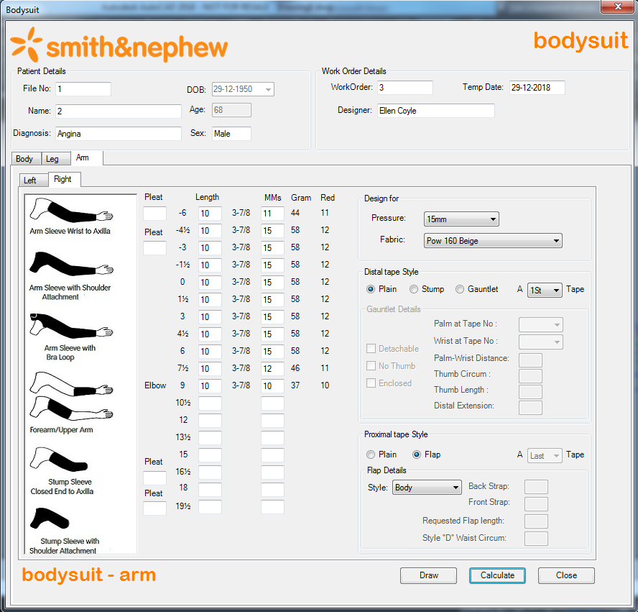

# Required Output:

# Body:



# Body – Draw Body:

* For Left and Right Arm, we need to draw Body using “Draw Body” button in Body tab.
* To draw Body, first we need to save Body, Left Leg and Right Leg details. Because, the “Draw Body” function reads some attribute values of Body, Left Leg and Right Leg block references.
* Until save the Body, Left Leg and Right Leg details, the “Draw Body” button remain disabled in Body tab. Only after saving those details, the “Draw Body” button will be enabled.

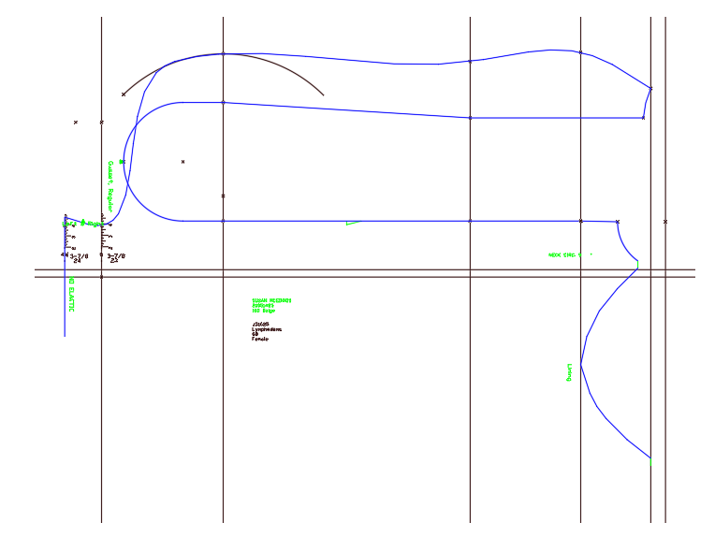

# Leg:

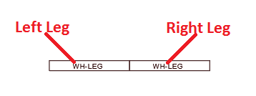

# Arm:

# Left Arm:

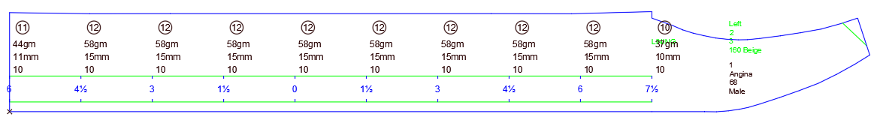

# Right Arm:

